Property website

**CSE326-INTERNET PROGRAMMING LABORATORY**



**Session:** 2020-21

**Submitted** **to**: **Submitted** **by**:

Shabnam Madam Aryan Maan-26 (11917211)

Sushil Kunwar-08 (11900275)

Nirmal Chhetri-35 (11916329)

INTRODUCTION TO PROJECT

Site provides online real-estate service committed to helping you make wise and profitable decision related to buying, selling, renting, and leasing of properties in India. We will provide a fresh new approach to our esteemed user to search for properties to buy or rent and list their properties for selling or leasing.

Number of wash rooms, price area, city, plot size, type of properties etc. Enter your search criteria and click search button to display the matching property. When you click the search button the property advertised will be shown. D3ealing with property two field is mandatory. Those are seller and purchaser registration.

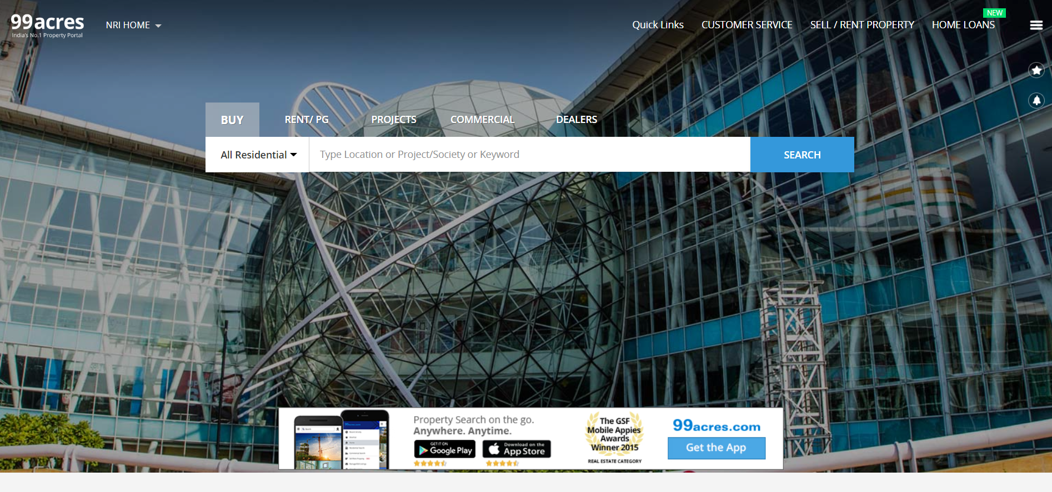

ABSTRACT OF THE PROJECT

This website is designed to attend to all your needs from buying properties, selling property or renting of property in India. Here you find the opportunity to invest your value of entire life. Property portals help us to maintain the database of various property and agent information. It not only help us to maintain information across the global environment.

If you looking to buy, sell, rent, invest and lease a property then here is the better place to think forward. We provide a one simple online form which required your basic information and we will assist in sort time period.

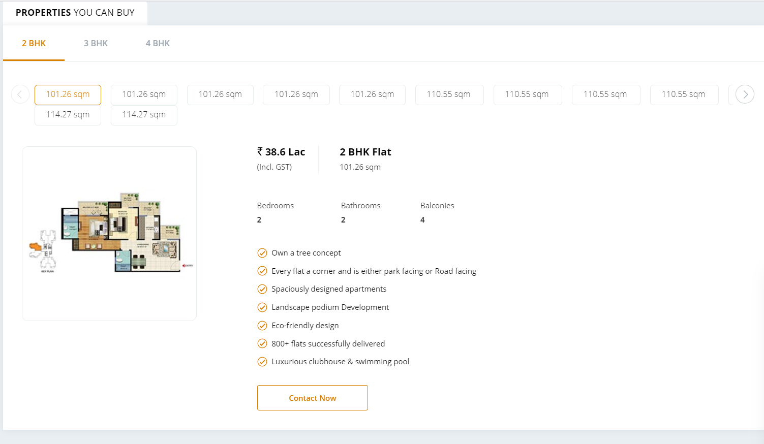

CONCLUSION

The project is to bring the real estate industry online and enabling real estate industries participants to benefit from the Internet site acts as an interface between individuals brokers and realtors. Here the user can advertise his properties for buying or selling purpose as well.

